ONEWAY Prec BY Age
/STATISTICS DESCRIPTIVES HOMOGENEITY WELCH
/PLOT MEANS
/MISSING ANALYSIS.

Oneway

Notes
Output Created |  | 05-May-2019 23:12:57
Comments
Input | Active Dataset | DataSet0
Input | Filter | <none>
Input | Weight | <none>
Input | Split File | <none>
Input | N of Rows in Working Data File | 30
Missing Value Handling | Definition of Missing | User-defined missing values are treated as missing.
Missing Value Handling | Cases Used | Statistics for each analysis are based on cases with no missing data for any variable in the analysis.
Syntax |  | ONEWAY Prec BY Age  /STATISTICS DESCRIPTIVES HOMOGENEITY WELCH  /PLOT MEANS  /MISSING ANALYSIS.
Resources | Processor Time | 00 00:00:00.156
Resources | Elapsed Time | 00 00:00:00.190

[DataSet0]

Descriptives
 | N | Mean | Std. Deviation | Std. Error | 95% Confidence Interval for Mean
 |  |  |  |  | Lower Bound | Upper Bound
18 | 1 | 20.0000 | . | . | . | .
19 | 2 | 32.5000 | 31.81981 | 22.50000 | -253.3896 | 318.3896
20 | 2 | 30.0000 | 42.42641 | 30.00000 | -351.1861 | 411.1861
21 | 2 | 45.0000 | 7.07107 | 5.00000 | -18.5310 | 108.5310
22 | 9 | 60.0000 | 42.57347 | 14.19116 | 27.2751 | 92.7249
23 | 1 | 95.0000 | . | . | . | .
24 | 1 | 70.0000 | . | . | . | .
25 | 1 | 55.0000 | . | . | . | .
28 | 2 | 27.5000 | 31.81981 | 22.50000 | -258.3896 | 313.3896
30 | 1 | 125.0000 | . | . | . | .
41 | 1 | 20.0000 | . | . | . | .
43 | 1 | 10.0000 | . | . | . | .
48 | 3 | 28.3333 | 22.54625 | 13.01708 | -27.6747 | 84.3413
52 | 1 | 20.0000 | . | . | . | .
56 | 1 | 10.0000 | . | . | . | .
58 | 1 | 15.0000 | . | . | . | .
Total | 30 | 44.5000 | 36.42067 | 6.64947 | 30.9003 | 58.0997

Descriptives
 | Minimum | Maximum
18 | 20.00 | 20.00
19 | 10.00 | 55.00
20 | .00 | 60.00
21 | 40.00 | 50.00
22 | 5.00 | 130.00
23 | 95.00 | 95.00
24 | 70.00 | 70.00
25 | 55.00 | 55.00
28 | 5.00 | 50.00
30 | 125.00 | 125.00
41 | 20.00 | 20.00
43 | 10.00 | 10.00
48 | 5.00 | 50.00
52 | 20.00 | 20.00
56 | 10.00 | 10.00
58 | 15.00 | 15.00
Total | .00 | 130.00

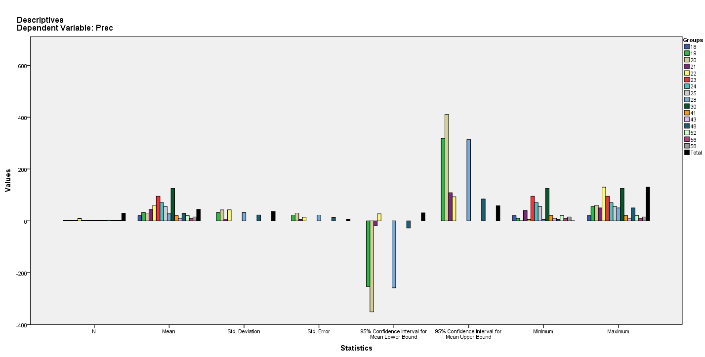

Test of Homogeneity of Variances
Prec
Levene Statistic | df1 | df2 | Sig.
1.032ª | 5 | 14 | .437
a. Groups with only one case are ignored in computing the test of homogeneity of variance for Prec.

ANOVA
Prec
 | Sum of Squares | df | Mean Square | F | Sig.
Between Groups | 19075.833 | 15 | 1271.722 | .918 | .566
Within Groups | 19391.667 | 14 | 1385.119
Total | 38467.500 | 29

Robust Tests of Equality of Means^{b}
Prec
 | Statisticª | df1 | df2 | Sig.
Welch | . | . | . | .
a. Asymptotically F distributed.
b. Robust tests of equality of means cannot be performed for Prec because at least one group has the sum of case weights less than or equal to 1.

Means Plots

